**Task 11.Use Tkinter module for UI design**

**Aim**:

To use Tkinter module for UI design

**Problem 11.1. Write a Python GUI program to create a label and change the label font style (font name, bold, size) using tkinter module.**

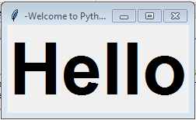

**Algorithm:**

1. Import tkinter module
2. Create a main window
3. Create a label with desired text
4. Add the label to the main window using pack() method
5. Define a function to change font style
6. Create a button to call the function when clicked
7. Add the button to the main window using pack() method
8. Start the main loop.

**Program:**

import tkinter as tk

# Function to change font style

def change_font():

label.config(font=("Arial", 18, "bold"))

# Create main window

root = tk.Tk()

# Create label with desired text

label = tk.Label(root, text="Hello, World!", font=("Helvetica", 14))

# Add label to main window

label.pack()

# Create button to change font style

button = tk.Button(root, text="Change Font", command=change_font)

# Add button to main window

button.pack()

# Start the main loop

root.mainloop()

**Output:**

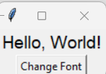

**Task 11.2: Write a Python to Create a** Basic Calculator App **using the** Tkinter **module**

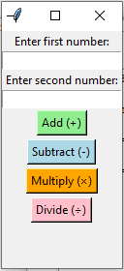

**Algorithm:**

1. Start the program.
2. Import the tkinter module.
3. Create the main window using Tk().
4. Add input boxes to enter two numbers.
5. Create buttons for operations: Add, Subtract, Multiply, and Divide.
6. When a button is clicked,
7. Read both numbers from the input boxes.
8. Perform the selected operation.
9. Display the result in a label.
10. Run the main loop to keep the window open.
11. Stop the program when the window is closed.

**Program:**

import tkinter as tk

def add():

try:

result = float(num1_entry.get()) + float(num2_entry.get())

result_label.config(text=f"Result: {result}")

except ValueError:

result_label.config(text="Please enter valid numbers!")

def subtract():

try:

result = float(num1_entry.get()) - float(num2_entry.get())

result_label.config(text=f"Result: {result}")

except ValueError:

result_label.config(text="Please enter valid numbers!")

def multiply():

try:

result = float(num1_entry.get()) * float(num2_entry.get())

result_label.config(text=f"Result: {result}")

except ValueError:

result_label.config(text="Please enter valid numbers!")

def divide():

try:

num1 = float(num1_entry.get())

num2 = float(num2_entry.get())

if num2 == 0:

result_label.config(text="Cannot divide by zero!")

else:

result = num1 / num2

result_label.config(text=f"Result: {result:.2f}")

except ValueError:

result_label.config(text="Please enter valid numbers!")

# Create main window

root = tk.Tk()

root.title("Basic Calculator")

# Input fields

tk.Label(root, text="Enter first number:").pack()

num1_entry = tk.Entry(root)

num1_entry.pack()

tk.Label(root, text="Enter second number:").pack()

num2_entry = tk.Entry(root)

num2_entry.pack()

# Operation buttons

tk.Button(root, text="Add (+)", bg="lightgreen", command=add).pack(pady=2)

tk.Button(root, text="Subtract (-)", bg="lightblue", command=subtract).pack(pady=2)

tk.Button(root, text="Multiply (×)", bg="orange", command=multiply).pack(pady=2)

tk.Button(root, text="Divide (÷)", bg="pink", command=divide).pack(pady=2)

# Result label

result_label = tk.Label(root, text="", font=("Arial", 12, "bold"))

result_label.pack(pady=10)

root.mainloop()

Output:

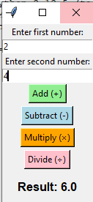 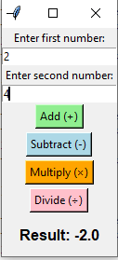 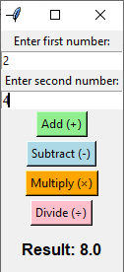 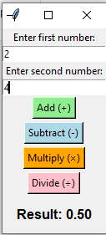

**Result:** Thus the Program using Tkinter module for UI design was executed and verified successfully.